Section 13



* added at the bottom of the body of index.html when we want to link it with index.js

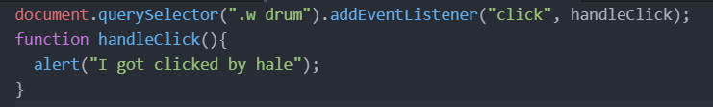

* clicking the button with class name w drum will make I got clicked by hale to be alerted.



* if we use hadleClick() with braces like this. The handleClick function will be executed just when the page loads.

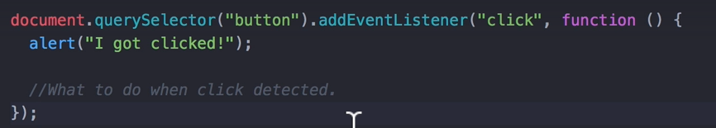

* you can also use anonymous functions
* you can put what ever you want between the braces and it will be executed when the click is made

$0

-if you select something in the Elements section in inspect Element

-then you can access it by using $0 in console

-you can do things like $0.innerHTML

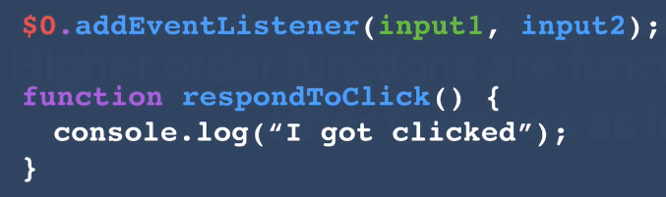

Higher Order Functions

-are functions that can take other functions as inputs

-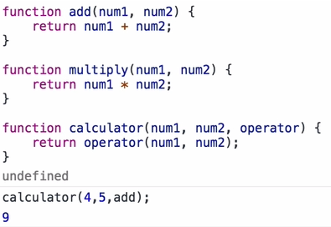

debugger;

-lets you go through the function in detail

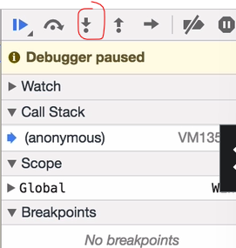 -you use the circled button